How to Install VMware Workstation Player on Ubuntu 20.04

In virtualization, a hypervisor is installed on a physical machine (host) and used to deploy virtual machines (guests) which are isolated from the host. Each virtual machine is allocated a share of resources such as memory, CPU, disk space, video drivers, and network adapters all in a virtual format. The concept of virtualization comes in handy when you want to deploy multiple systems but with limited resources. It’s cost-effective and allows users to try out various operating systems without purchasing physical PCs.

Since its inception, [VMware](https://www.vmware.com/) has revolutionized virtualization. VMWare workstation player, a product from VMware, is a popular hypervisor that is mostly used for home/desktop environments. It comes as a good alternative to VirtualBox and KVM. In this tutorial, we shall seek to install VMware Workstation on Ubuntu 20.04.

**Prerequisites**

Before you set sail, ensure that you have an instance of Ubuntu 20.04 with a GUI (Graphical User Interface) and a stable internet connection for updating and downloading packages.

**Step 1: Update system repository**

A couple of packages are required before diving into the actual installation of the VMware Workstation. Firstly, update the package index.

**$ sudo apt update**

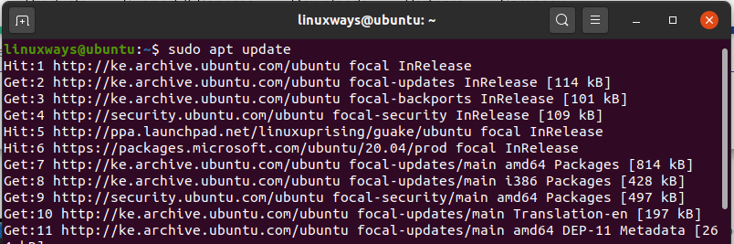

Step 2. **Install prerequisite packages**

Then install the essential software packages such as GCC and Linux-headers as follows.

**$ sudo apt install gcc build-essential linux-headers-$(uname -r)**

From the output, you can see that the packages were already installed at an earlier time, but in your case, you will be prompted to continue with the installation in case the packages are not yet installed.

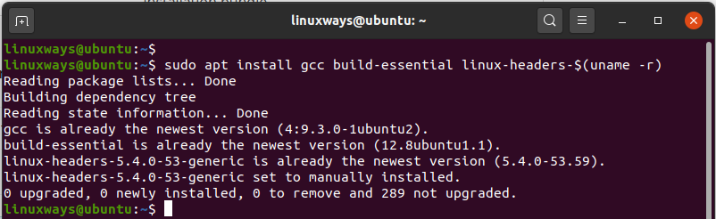

Step 2. **Install prerequisite packages**

Then install the essential software packages such as GCC and Linux-headers as follows.

**$ sudo apt install gcc build-essential linux-headers-$(uname -r)**

From the output, you can see that the packages were already installed at an earlier time, but in your case, you will be prompted to continue with the installation in case the packages are not yet installed.



**Step 3: Download VMware installer bundle**

With the essential packages in place, the next step will be to download the installer bundle that we will execute to install VMware Workstation Pro. We will install VMware Workstation Pro 16.1.0 which, as I’m writing this guide, is the latest release.

So, head out to VMware’s product section. Click on the ‘Download Now’ link located in the ‘[WorkStation 16 Pro for Linux](https://www.vmware.com/products/workstation-pro/workstation-pro-evaluation.html)’ section as shown.

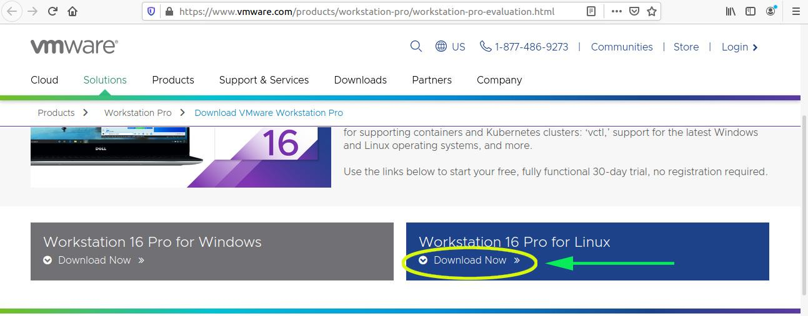

The pop-up dialogue will prompt you to choose what you’d want to do. Click on the ‘**Save file**’ option and hit the ‘**Ok**’ button. This downloads the file in your ‘**Downloads**’ folder located in your home directory.

The installation bundle is about 500MB in size. So ensure your internet connection is fast and reliable.

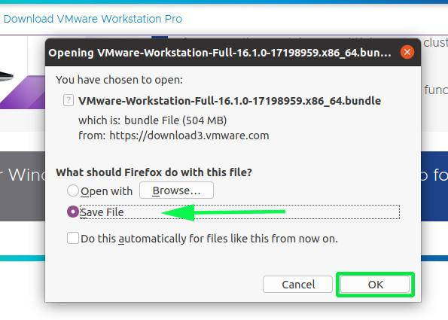

Once the download is over, you can confirm that the bundle is in place as expected by navigating to the ‘**Downloads**’ directory and confirming its presence using the **ls** command.

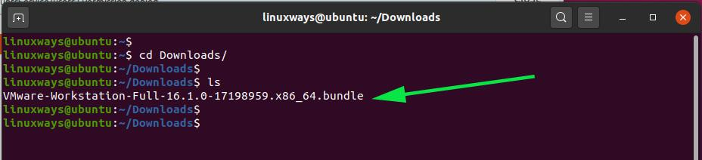

**Step 4: Run the VMware installer bundle**

Thereafter assign execute permissions to the VMware installer bundle.

So, use the Linux **chmod** command as shown.

**$ sudo chmod +x VMware-Workstation-*.bundle**

Confirm the assignment of the execute permissions using the command:

**$ ls -l**

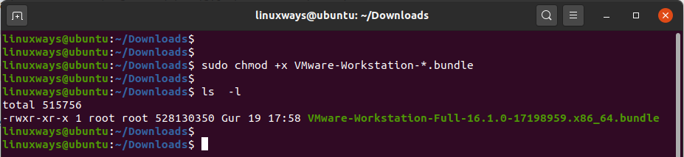

Great, you can now proceed and run the installer as shown.

**$ sudo ./VMware-Workstation-*.bundle**

This command will perform the extraction of the installer bundle and install VMware. This lasts approximately 3 minutes.

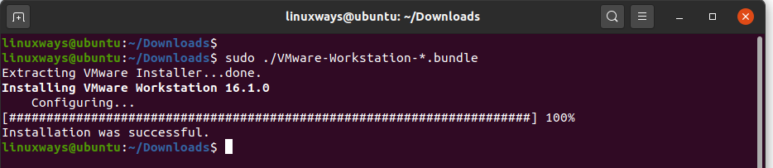

**Step 5: Launch VMware and complete the setup**

We are done doing the heavy lifting. The remaining part will be to launch the installer and complete the setup graphically.

Click on the ‘**Activities**’ tab on the far left corner and search for VMware. Click on the VMware icon pointed by an arrow.

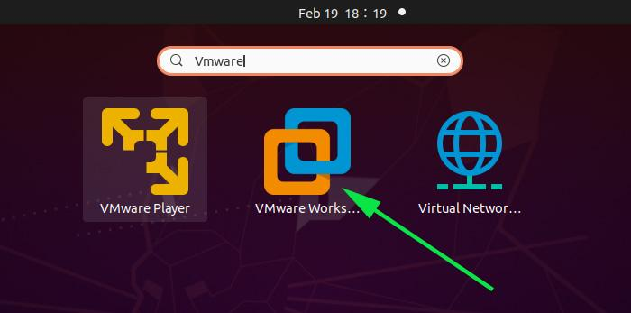

Accept the VMware License Agreement and hit the ‘**Next’** button.

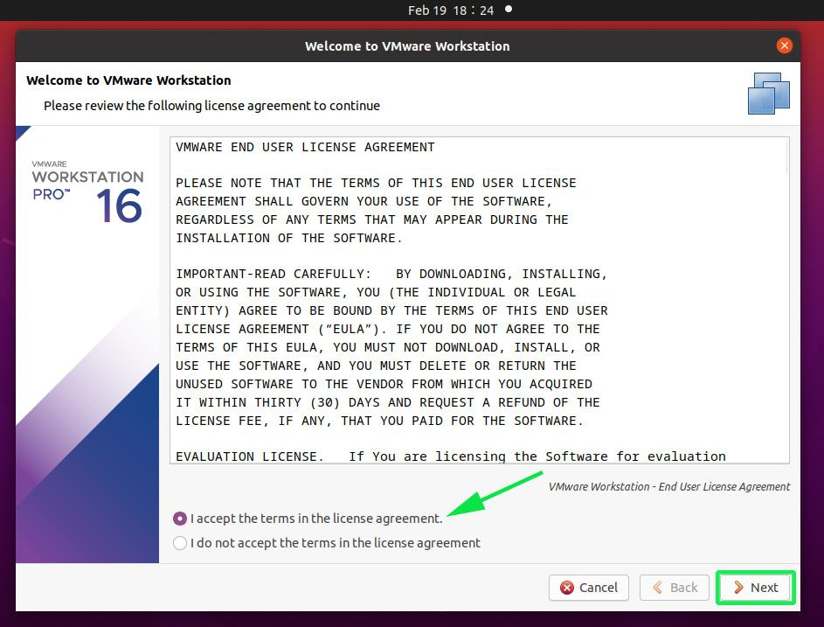

Again, you will have to accept the EULA agreement, this time for the VMware-OVF Tool component for Linux. Then click ‘**Next**’.

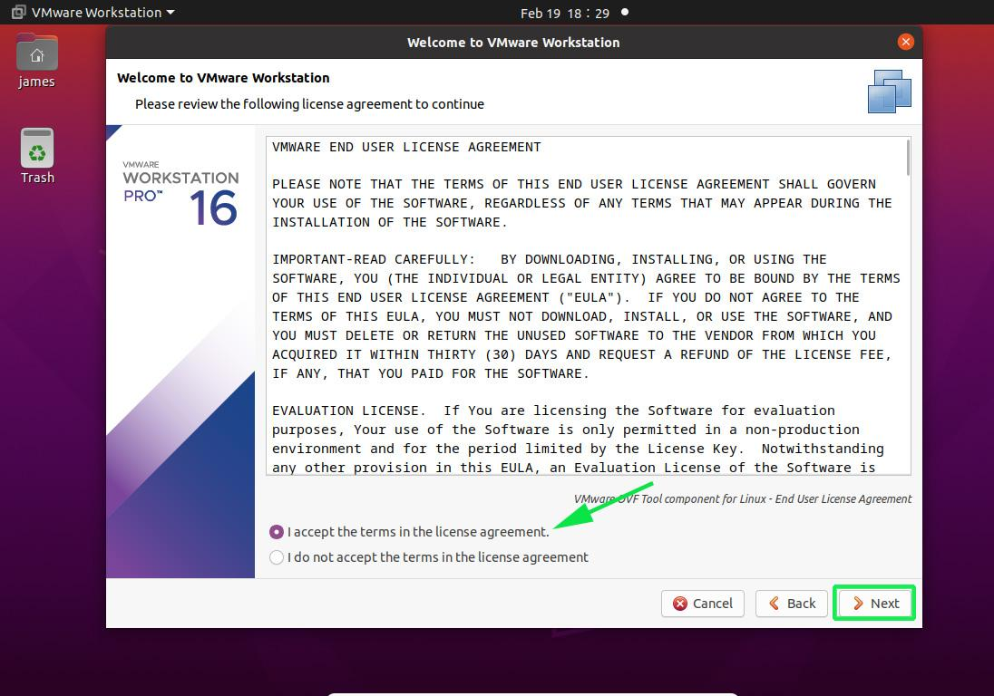

In the next step, feel free to determine whether or not you would like VMware to check for updates on boot-up. In my case, I have selected VMware to check for updates once I boot up my system.

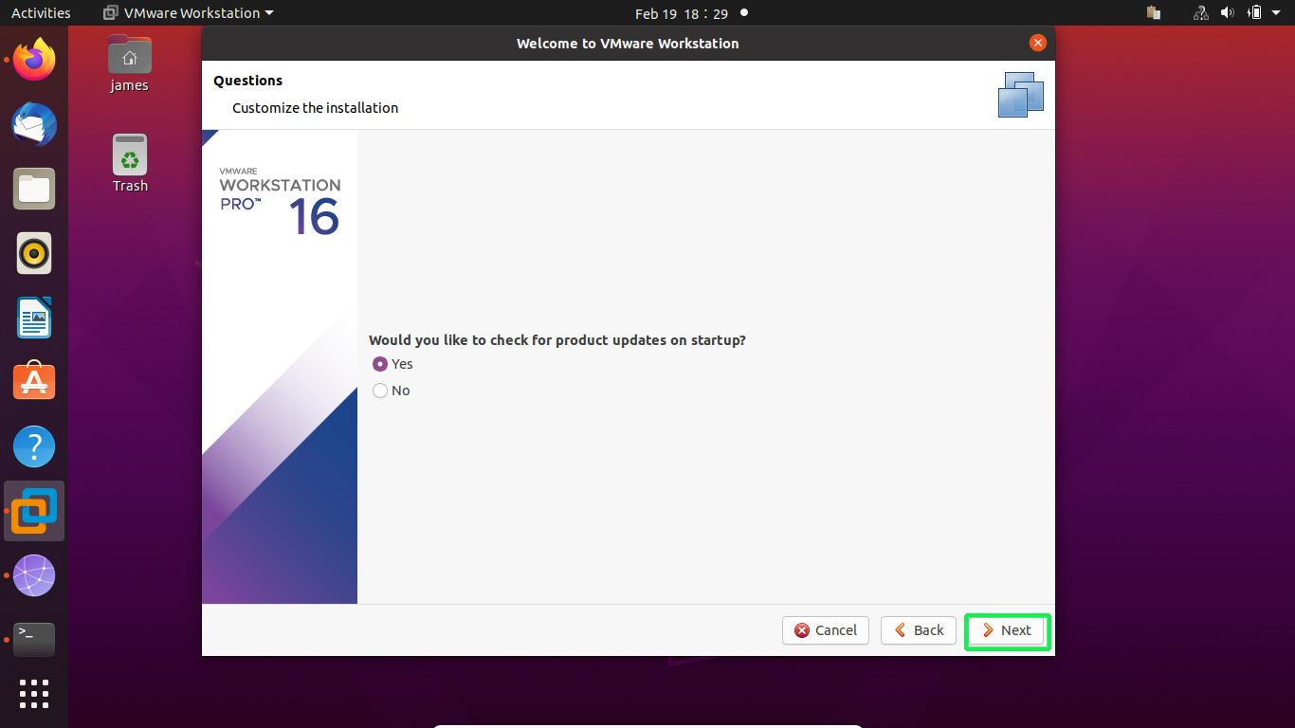

You can decide to be a part of the customer experience program or simply decline. This is set to ‘Yes’ by default. If you don’t feel like it, select ‘No’.

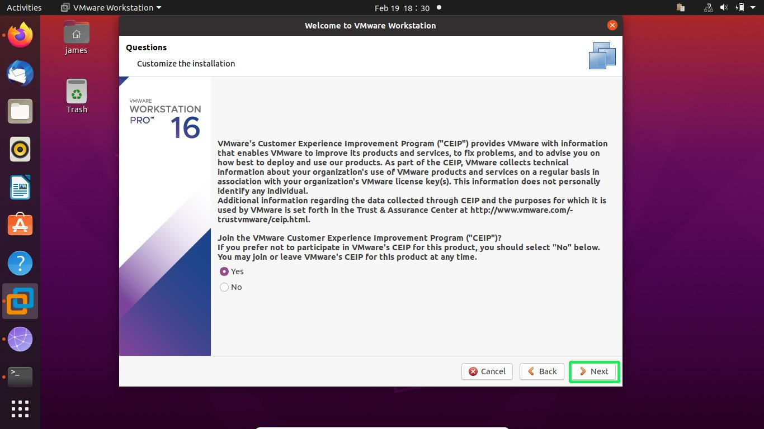

VMWare workstation is a proprietary tool. Thankfully, you can evaluate it for a 30-day window after which you will be required to purchase a license. Therefore, select the second option to try VMware for a one-month period and click the **‘Finish**’ button.

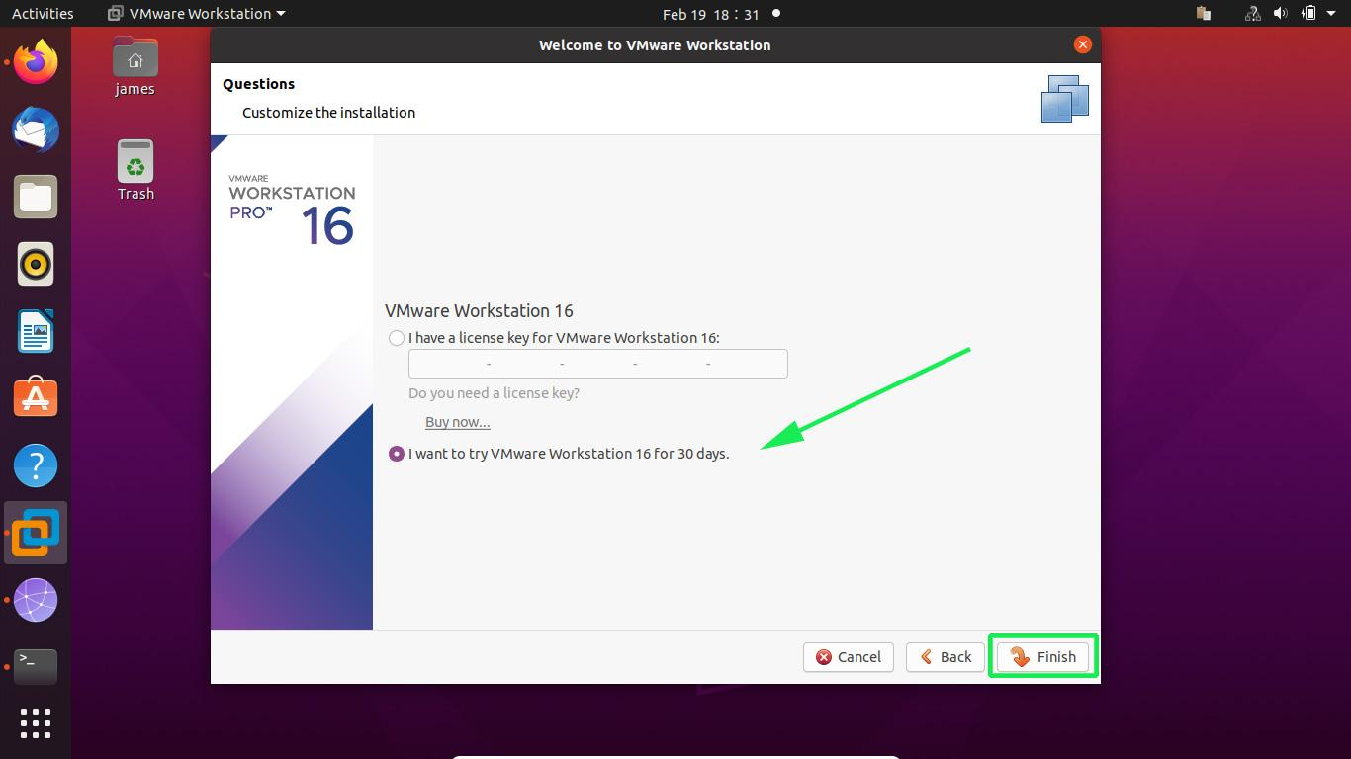

Enter your password to authenticate and hit the ‘**Authenticate**’ button.

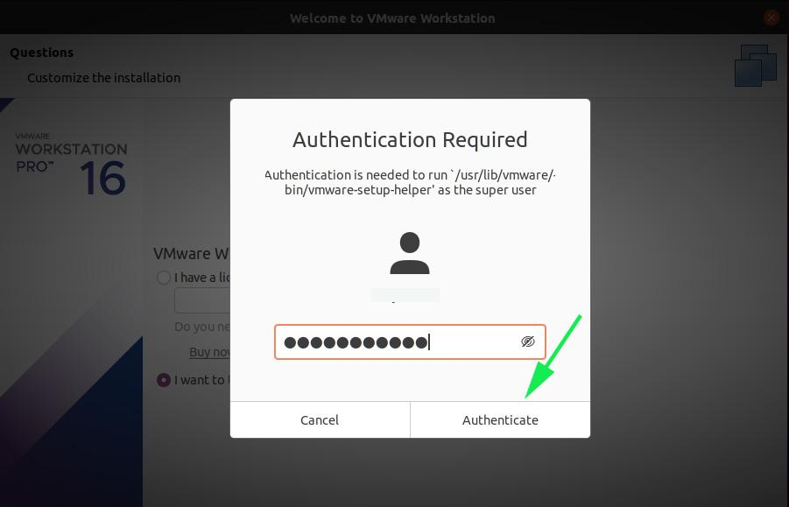

This draws the curtain on the installation of VMware WorkStation Pro. Click on the ‘**Ok**’ button.